Cache policy 1: oldest, 2: largest

1

Number of Files

10000

File per second Poisson Value

100

Pareto File Size Request Alpha

2

pareto File Request Beta

.5

Cache Size

500

numSeconds

1000

Pareto File Size Alpha

1

Pareto File Size Beta

5

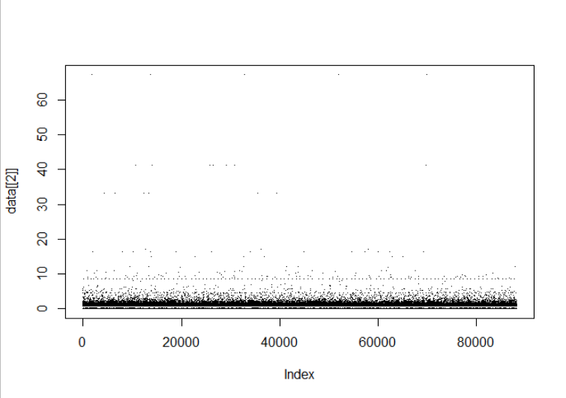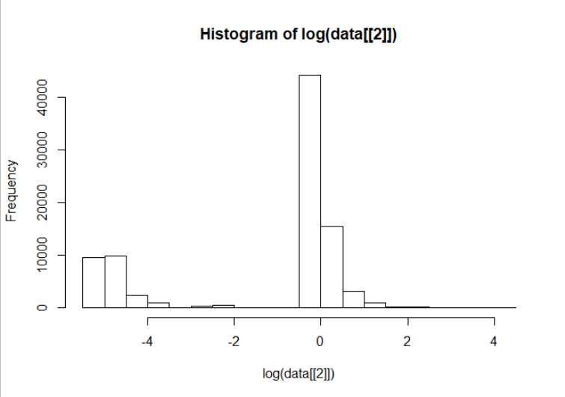

> mean(data[[2]])

[1] 0.7968518

> median(data[[2]])

[1] 0.809624

Cache policy 1: oldest, 2: largest

2

Number of Files

10000

File per second Poisson Value

100

Pareto File Size Request Alpha

2

pareto File Request Beta

.5

Cache Size

500

numSeconds

1000

Pareto File Size Alpha

1

Pareto File Size Beta

5

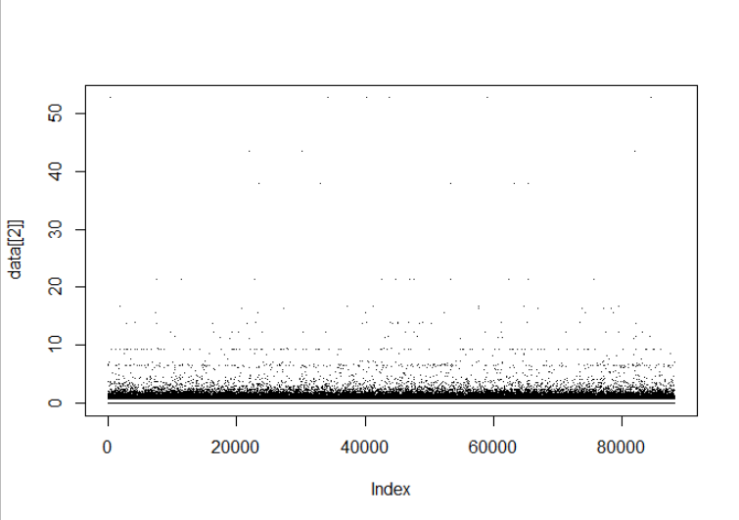

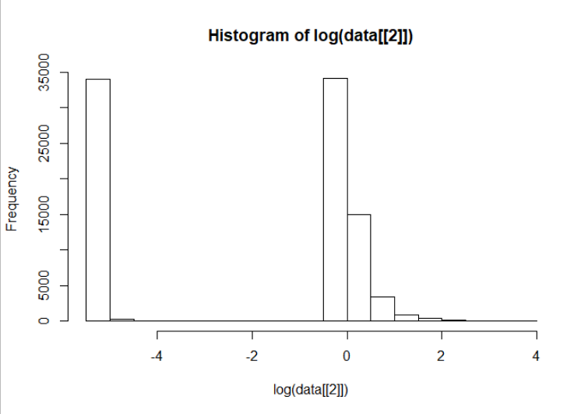

[1] 0.7034194

> median(data[[2]])

[1] 0.794556

Cache policy 1: oldest, 2: largest

2

Number of Files

10000

File per second Poisson Value

100

Pareto File Size Request Alpha

5

pareto File Request Beta

.1

Cache Size

500

numSeconds

1000

Pareto File Size Alpha

1

Pareto File Size Beta

5

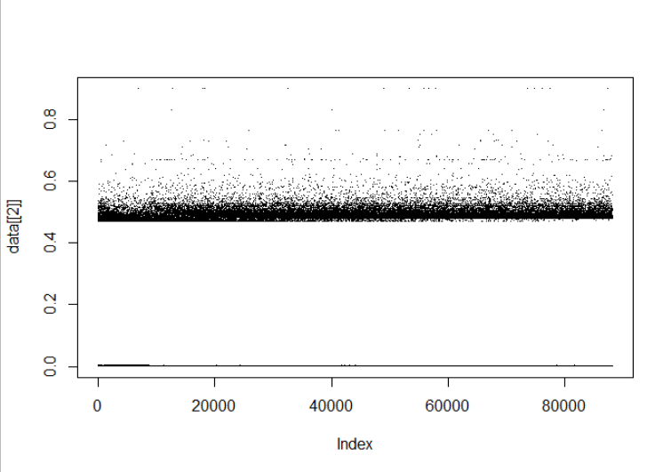

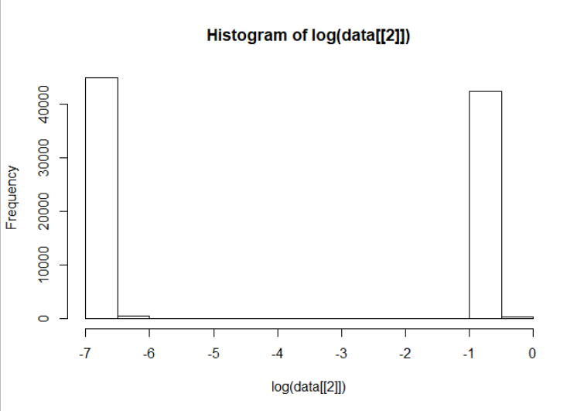

> mean(data[[2]])

[1] 0.2392792

> median(data[[2]])

[1] 0.00130081

Cache policy 1: oldest, 2: largest

1

Number of Files

10000

File per second Poisson Value

100

Pareto File Size Request Alpha

5

pareto File Request Beta

.1

Cache Size

500

numSeconds

1000

Pareto File Size Alpha

1

Pareto File Size Beta

5



[1] 0.2392792

> median(data[[2]])

[1] 0.00130081

Cache policy 1: oldest, 2: largest

1

Number of Files

10000

File per second Poisson Value

100

Pareto File Size Alpha

2

pareto File Size Beta

.5

Cache Size

500

numSeconds

1000

Pareto File Request percentage Alpha

1

Pareto File Request percentage Beta

20

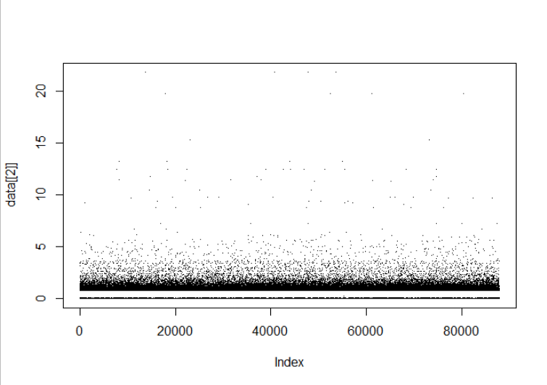

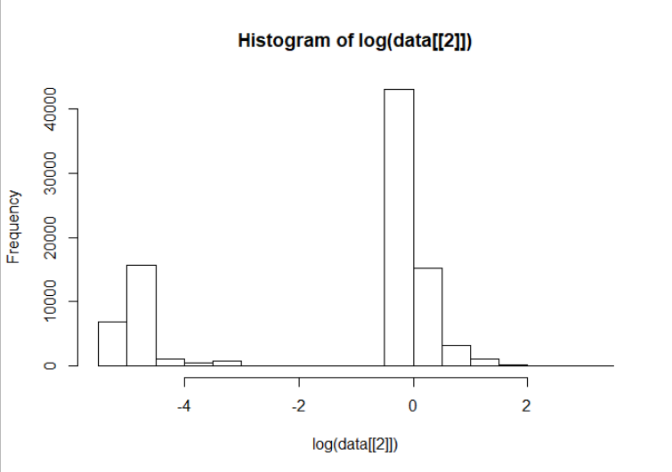

> mean(data[[2]])

[1] 0.7587315

> median(data[[2]])

[1] 0.80542

Cache policy 1: oldest, 2: largest

2

Number of Files

10000

File per second Poisson Value

100

Pareto File Size Alpha

2

pareto File Size Beta

.5

Cache Size

500

numSeconds

1000

Pareto File Request percentage Alpha

1

Pareto File Request percentage Beta

20

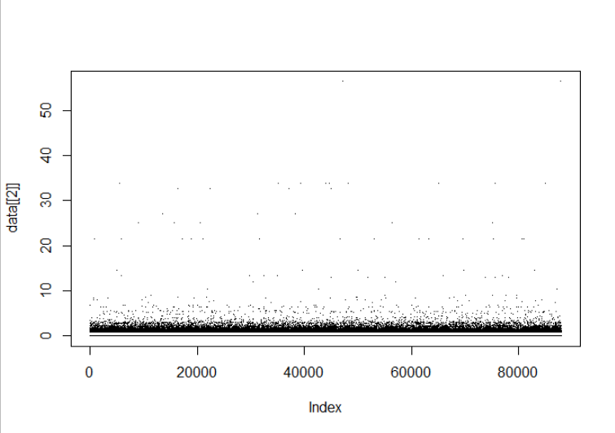

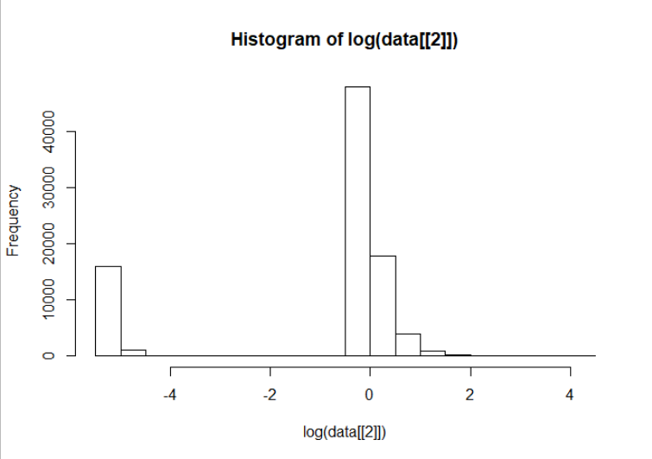

> mean(data[[2]])

[1] 0.8730773

> median(data[[2]])

[1] 0.859924